How to hire your gown

- Go to the William Northam website and select ‘Graduation’ from the menu:
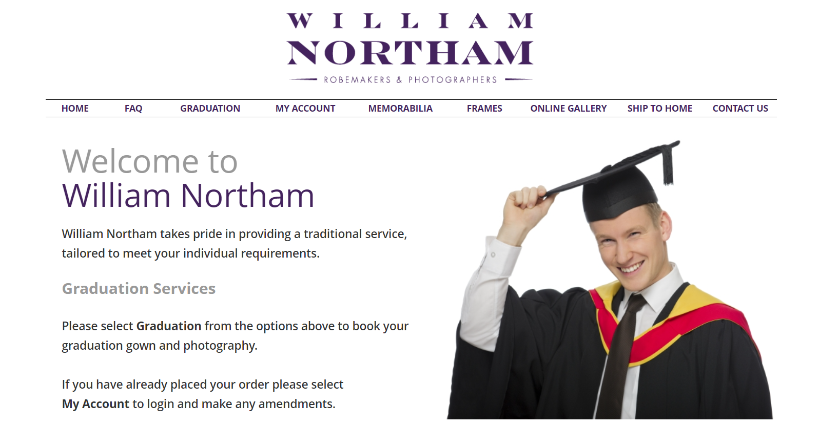

- Enter ‘University of Huddersfield’ on the ‘Please Select your Institution’ field:
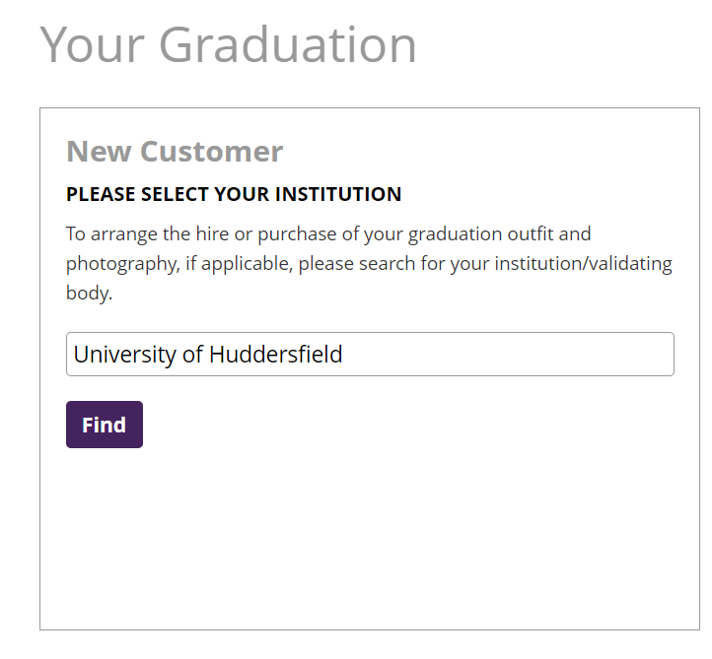

- The University will automatically show on the page that follows, select ‘Submit’:
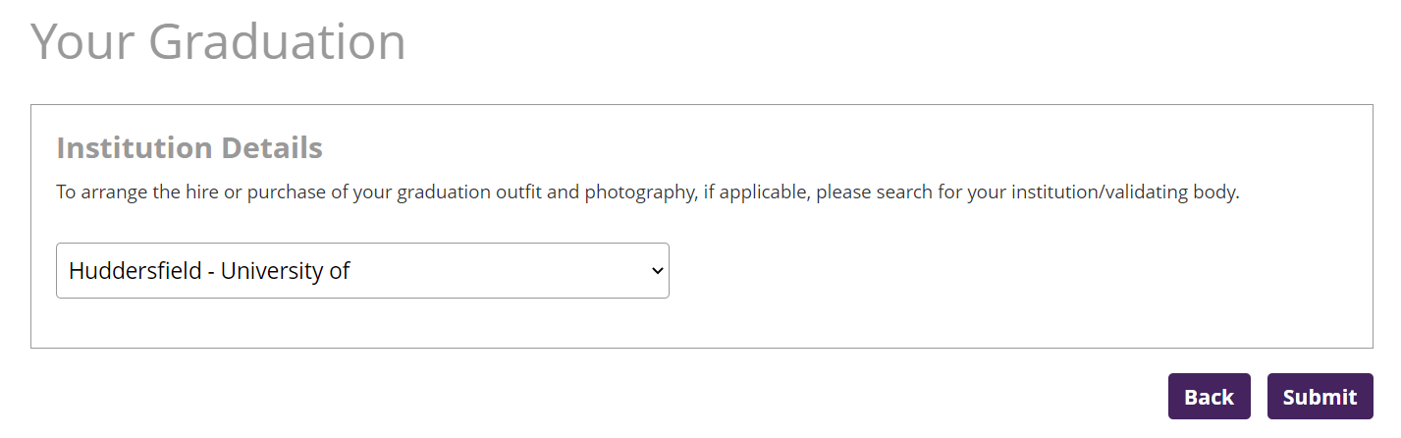

- Provide your Student ID details by giving your University of Huddersfield seven-digit Student ID number, your surname as it was registered with the University of Huddersfield, and provide the email address to which you would like your order confirmation to be sent to (this does not need to be your student email address). Once complete, please select ‘Submit’:
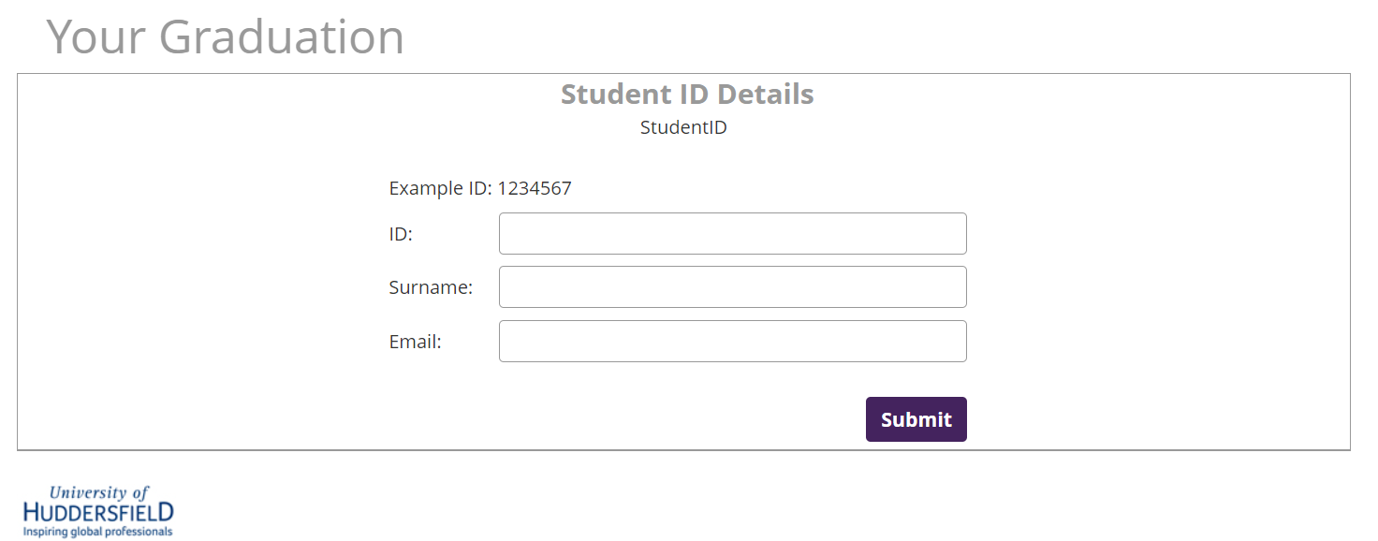

- The following page will provide you with confirmation of the ceremony to which you have been invited. Please select ‘Next’ to continue with the gown hire process:
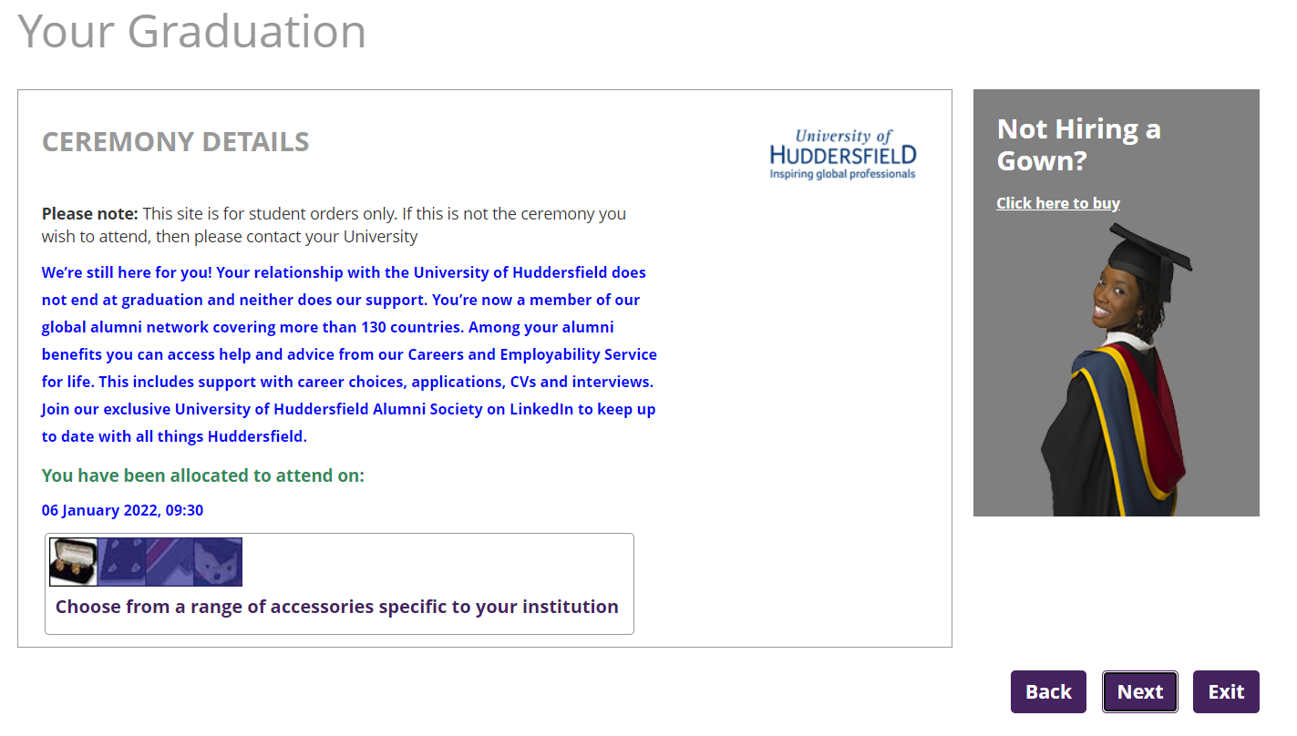
- The next webpage will again confirm the ceremony you have been invited and also confirm the award which you will be receiving. Please press ‘Next’ to continue with the booking process.
If any of these details are incorrect, please contact graduation@hud.ac.uk before continuing.

- Please provide your personal information to create an account with the William Northam website to complete your order. Once you have provided all of your information, please press ‘Next’ to continue:
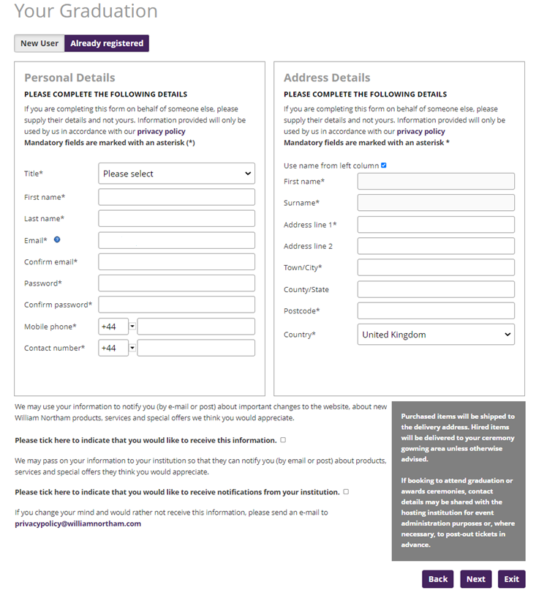

- To proceed to order your gown, please select the button that says ‘Click here to start your order’
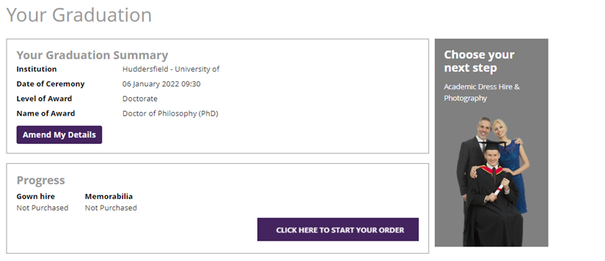
- This page will ask you to provide your sizing information for your gown and hat hire. You will automatically be provided with the appropriate colourways for the award that you will be receiving. You have the option to hire or buy each piece of attire.

Once you have completed your size details and selected your hire options, please select ‘Next’:
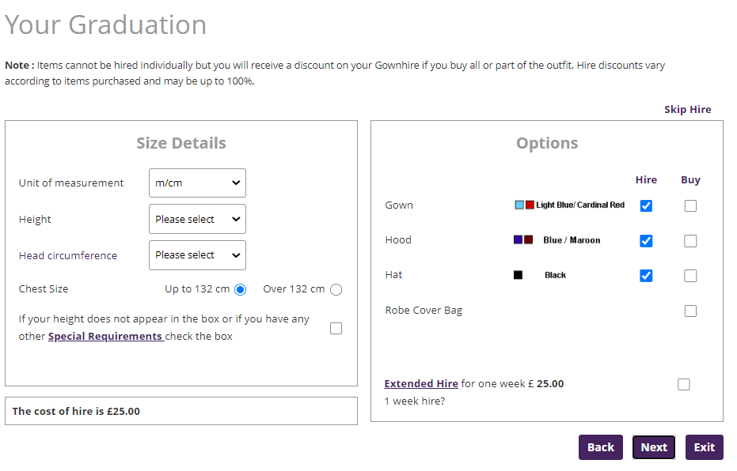
- You will be provided with a summary of your order. To edit any of your gown hire details, select ‘Back’. To finish your order select ‘Checkout Now’:

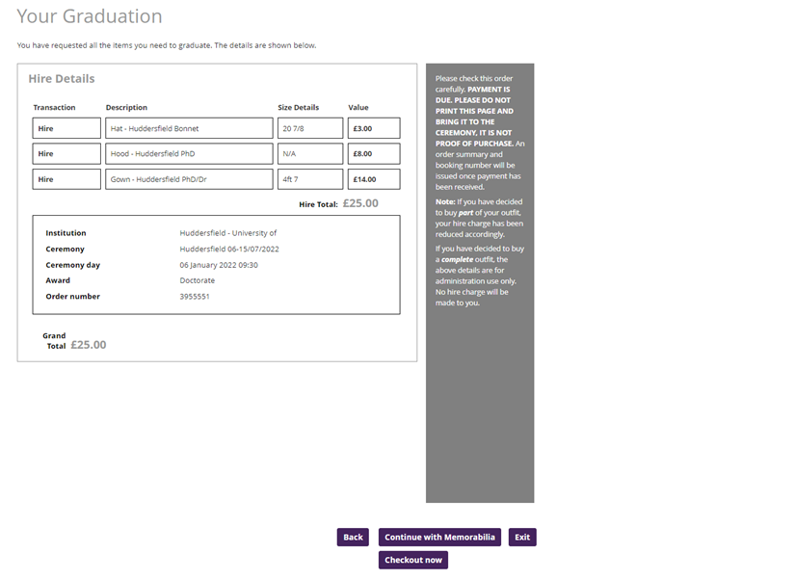

- When you select checkout now, you will be provided with Northam’s terms and conditions to review and accept:
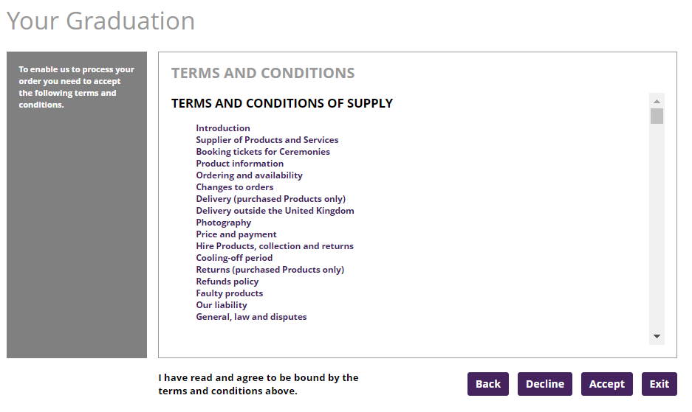
- You will be asked to review and confirm your personal details and the billing address. This page will show the details you provided previously so that you can update them if required. Once ready to proceed, please select ‘Next’:

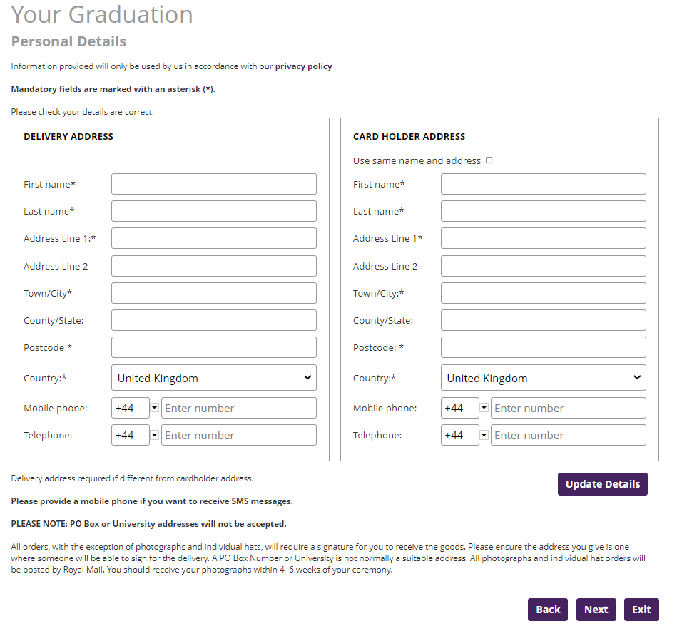

- You will be provided with an overview of your order. Please select ‘Order with obligation to pay’:
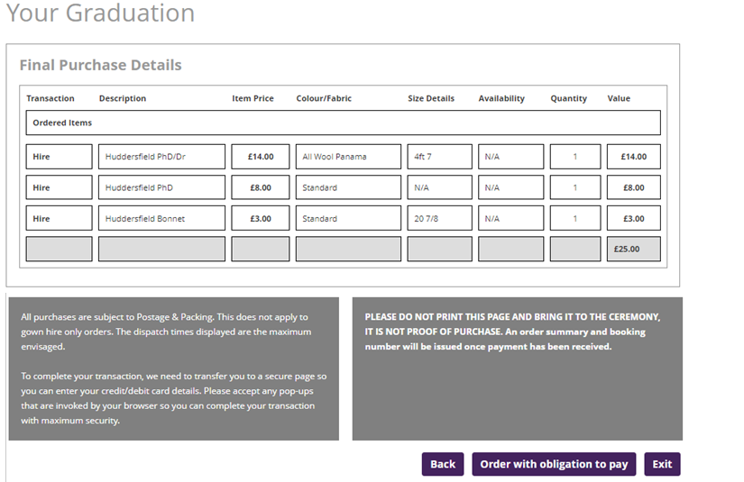

- You will then be taken to a secure payment page, to provide your card details to pay for the gown hire. Please provide your details and select ‘Pay Now’. Then follow the rest of the screens through to complete your order.
