Accessibility for Online PowerPoints

Top Tips: -

- Font still matters - Partially sighted students read better from an Arial font (supported by RNIB) Navy on a white background is recommended
- Size matters - Font size should be no less than 24 on a PowerPoint Presentation
- Spacing - Spacing sentences and bullet points well is very important
- Bullet Points - It is better to use arrows or squares as they are less likely to move and distort as the student is reading.
- Contrast - When using backgrounds check the contrast is accessible, you can do this by visiting contrast-ratio.com

Use Placeholder’s - don’t add text boxes

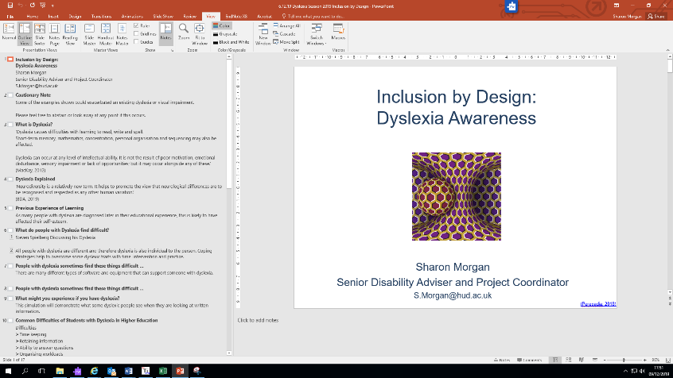

Change the font in seconds
- View
- Outline view
- Select
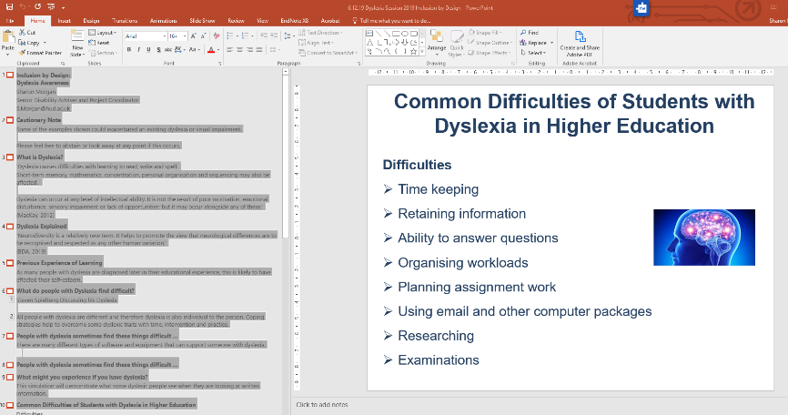
- Home
- Choose font, colour, size

Using Alt Text – This is important as when a student uses a screen reader it cannot recognise the picture unless a description is added to the Alt Text box so this can be read out aloud.
- Decorative images: - If the picture is purely for decoration this is not necessary as the information does not have to be described.
- Images used or referred to for learning: - if the picture is used for the purpose of explaining or reiterating information (as in the example below) it should have the Alt Text box completed.

Colour should not be used on its own to indicate a relationship – bold text or add shapes to a graph so that students can differentiate the graph more easily.

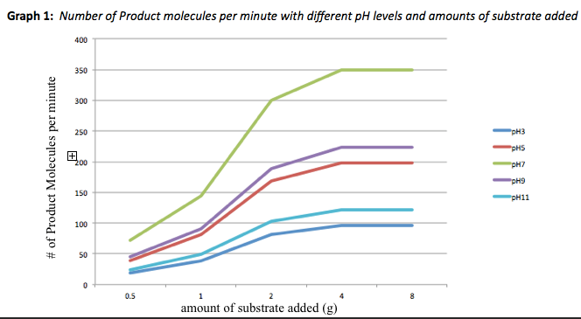
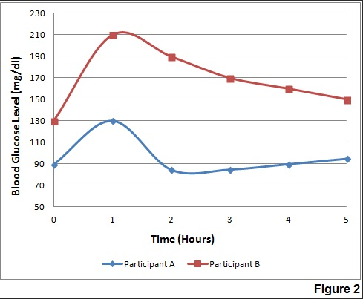

Caption all film clips used online

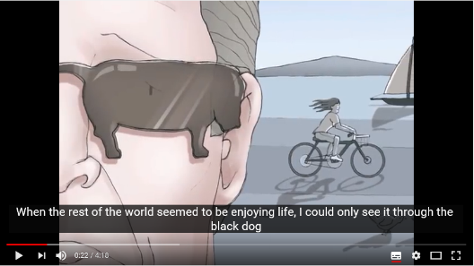

Only use / buy third party resources that support our digital accessibility requirements.

